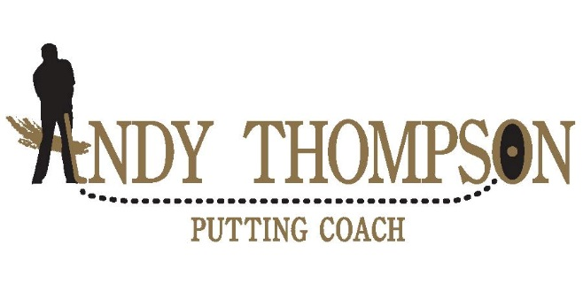
ON LINE LESSON Questionnaire
I realize there are a lot of questions here. That’s because I want to do as good a job as possible in helping you!
Please answer what you can. Use N/A if you don’t know
The more information I get the better

Natural Hand Usage—(eating, throwing,—L/R/Ambidextrious)___________
Putt LH or RH______________________
Beliefs (SBST, ARC, INSIDE TO INSIDE, OTHER_______________________
Putting Instruction in the Past?____________________________
With Whom_____________________Likes/Dislikes_____________________________
How Often____________When?___________
Email___________________________________________
Phone______________________________________________
Avg. Score or Handicap__________________________________________________
Avg. Rounds per year______________________________________________________
# Years playing________________________________
List any putting stats of yours__________________________________________
Putting Goals_____________________________________________________________

Typical Miss (R or L)___________________________________
Typical Miss (Short or Long)_______________________________

Rate yourself 1(Poor) to 5(Great)
Speed/Distance Contol___________
Short Putts(4’ or less)_________________
5’ to 12’________________________
Green Reading_______________

How many hours per week of putting practice________________________
Putting training aids you use (list)_______________________________________

Was your putter fit for you?_______Where?_______________________________
What is length of your putter?_____________________________________________
How many inches from your crease in your wrist to floor with arms hanging down?______________________________
What Brand/Model Putter do you use the most?____________________________________________________________
Grip type and size_____________________________________________________
How many putters do you own?_______________Use?_______________________
Tend to Decelerate, Overaccelerate or about right?______________________________________________________
Do you have the yips often, always, rarely or never?__________________
If so are they on short putts, long putts, all putts?_______________________________
Putting styles of gripping used (Yes or No)
Standard_______________
Opposite hand Low?___________________
Claw_________________________
Thumbs side by side___________________
Other_____________________________________
Green Reading (Yes or No)
AimPoint Express ________________________________
Eyes/Visual from behind the ball________________________________
Eyes/Visual from behind the hole________________________________
Eyes/Visual from the side_______________________________________
AimChart____________________________________________________
Experience playing the course__________________________________
Guess_______________________________________________________
Do you consider yourself a good green-reader?______________________

Imagery, mental and visual
Do you see a curved line where you expect the putt to roll on?_________
Do you visualize the putt going in the hole?______________________
Positive or Negative before putting?________________________________
Don’t have any thoughts___________________________
What is the weight balance between L and R Feet? (50/50, 60/40 front, etc._______________________________________________
Where do you feel you are balanced from toe to heel?_________________________________________
Do you use a forward press?________________________________________
If so is it a trigger to take the putter back?________________________
Do you have another trigger to take the putter back?__________________
Ball Position 0-10 (0 = ball even with front foot, 5= Middle of stance and 10= ball even with back foot)___________________________________
Do you grip down on the putter?______________How much?______________
Breathing
Exhale/Inhale?_______________________
Hold Breath___________________________
Nothing Conscious__________________________
Other________________________________
Been on SAMPUTT before?____________________________________________
Been on Tomi before?_____________________________________________
Blast Motion?__________________________________
Quintec?_________________________________________________________
Results on any of them_________________________________________________
(please email reports if you have them.)
Do you use a line on the ball aimed at the target? ____________________
See a curve when you putt or aim at a spot?__________________________

